**Django-ERP User Manual**

**Basic Operation**

## 1. Login system

Enter the system address in the browser address bar and press Enter to open the following page

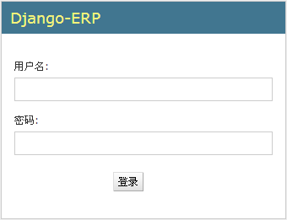

Please enter your user name and password and click the [Login] button to log in.

Tip: To log in, users must meet two conditions, and their permission settings [Valid] and [Staff Status] must be selected, as shown below

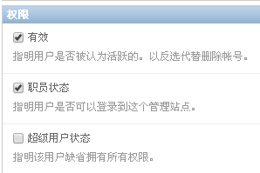

## 2. To-do tasks

After the user logs in to the system, he can click [To-do Tasks] in the upper right corner of the interface to view his pending approval process.



After clicking, the to-do tasks are displayed as follows:

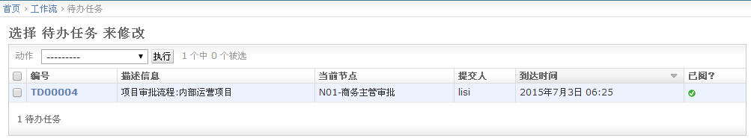

Click the link corresponding to the [Number] column to enter the detailed page, as shown below:

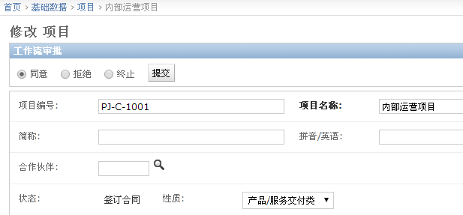

You can select [Agree], [Reject] or [Terminate] to submit. After clicking [Submit], the subsequent approver information will be displayed, as shown in the following figure:

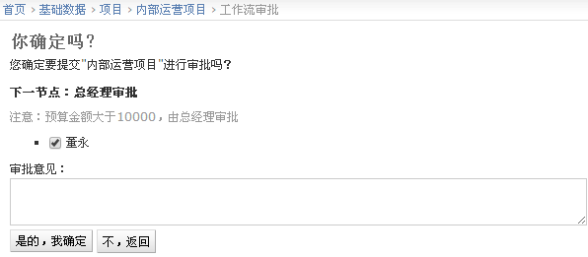

The submitted document cannot be modified, as shown below:

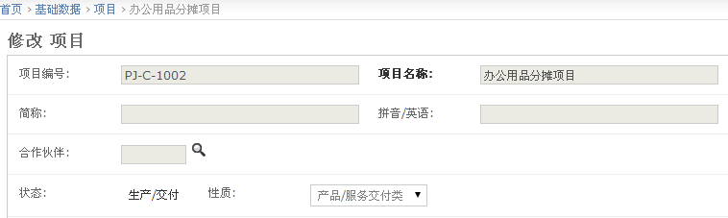

## 3. Add documents

Adding a document means entering a new document into the system. You can add a document in three ways:

1) On the home page, click the [Add] button, as shown below:

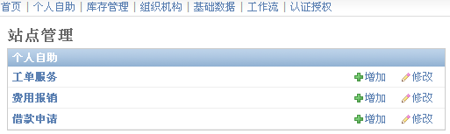

2) On the Edit/List page, click the [Add xx] button, as shown below

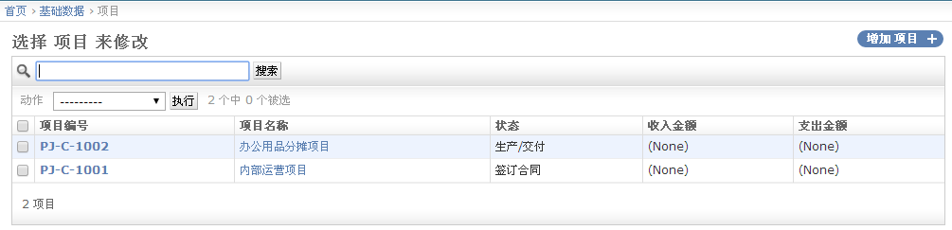

3) On the form page, click the [Save and Add Another] button. After saving the current document, an empty form will be displayed. After entering, click the [Save] button, as shown below:



The functions of the three buttons in the figure above are described as follows:

[Save and add another]: Save the current document, clear the page data, and generate a new document after saving again;

[Save and Continue Editing]: Save the current document without clearing the page data. No new document will be generated after saving again.

【Save】: After saving the current document, return to the list page;

## 4. Modify the document

On the list page, select a specific document and click the link in the [Number], [Name] or [Title] column, as shown below:

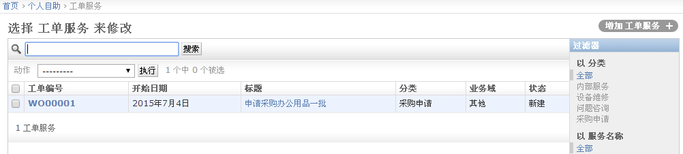

You can enter keywords in the search bar to search. The search of this system supports cross-field full-text search, and you can search the content of the specified field. After clicking the link, you will enter the form page, as shown below:

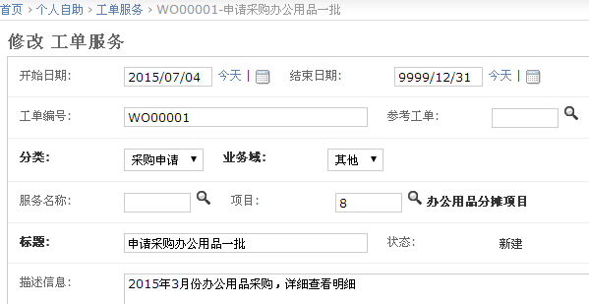

## 5. Submit documents

For a business that includes a workflow, the button bar on the form page is as follows:



For businesses that do not include workflow, the button bar on the form page is as follows:



After clicking the [Submit] button, the following interface is displayed:

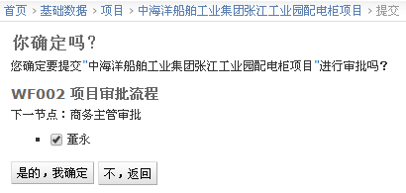

You can click the [Yes, I'm sure] button to submit for approval.

## 6. Change password

In the upper right corner of the page, click the [Change Password] link, as shown below



Open the following page:

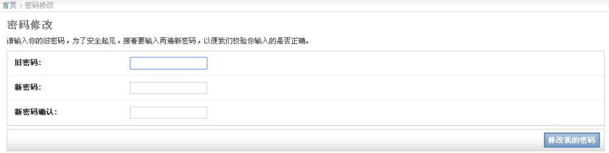

After entering the old and new passwords, click the [Change My Password] button to make them effective.